**Daily Scrum or Standup Meeting**

Team name: Group 2

Scrum Master: Max Edwards

Date:________February 23 2023_______________________

| **Team Member** | **What did you do since the last scrum?** | **What do you plan to do before the next scrum?** | **What obstacles do you have?** |
| --- | --- | --- | --- |
| Satchell Fausett | Finished the two endpoints for removal and adding money | Finish up the vehicle, migration endpoints | Cleaning up damage with bad database stuff. Review more Django |
| Jared Hansen | Reservation page and vehicle display | Component for checking out a car | Look at the authentication. |
| Chase Miller | Create vehicle and user posts are working | Talk to Satchell about getters for vehicle and user | School and NSA |
| Max Edwards | Made a sign page  Mental thought through the pipelining | Push up the sign in page and a component for the manager to adjust user status | No foreseeable obstacles |
|  |  |  |  |

# Burndown

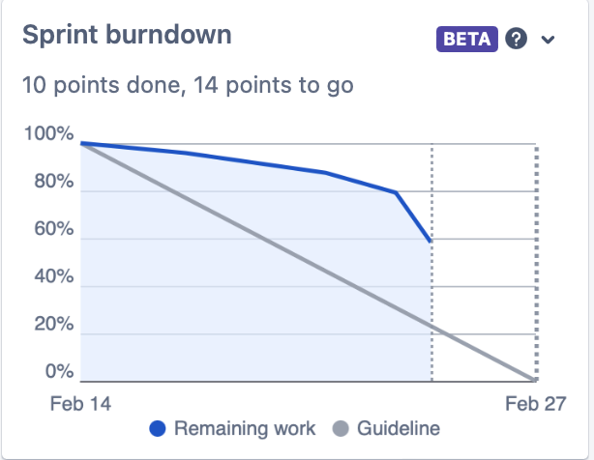

# 

# 

# 

# 

# Screenshot of your project board

